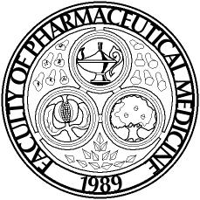 |  | 

Please fill in the whole form and send it to:

Faculty of Pharmaceutical Medicine
5-11 Theobalds Road
London
United Kingdom
WC1X 8SH

Name(s) of account holder(s).

Bank or Building Society account number

Branch sort code

Name and full postal address of your Bank or Building Society

To: The Manager | Bank/Building Society
Address

 | Postcode

Instruction to your
Bank or Building Society
to pay Direct Debits

Originator's Identification Number
809826

Reference/FPM Membership Number

Instruction to your Bank or Building Society
Please pay the Faculty of Pharmaceutical Medicine Direct Debits from the account detailed in this instruction subject to the safeguards assured by the Direct Debit Guarantee. I understand that this Instruction may remain with the Faculty of Pharmaceutical Medicine and, if so, details will be passed electronically to my Bank/Building Society.

Signature(s)

Date

Banks and Building Societies may not accept Direct Debit Instructions for some types of account

This guarantee should be detached and retained by the payer.

 | The Direct Debit Guarantee | 
This Guarantee is offered by all Banks and Building Societies that take part in the Direct Debit Scheme. The efficiency and security of the Scheme is monitored and protected by your own Bank or Building Society.

If the amounts to be paid or the payment dates change, the Faculty of Pharmaceutical Medicine will notify you 10 working days in advance of your account being debited or as otherwise agreed.

If an error is made by the Faculty of Pharmaceutical Medicine or your Bank or Building Society, you are guaranteed a full and immediate refund from your branch of the amount paid.

You can cancel a Direct Debit at any time by writing to your Bank or Building Society. Please also send a copy of your letter to us.

